May XX, 2022

Professor Stephen J. Schulhofer, Reporter

Professor Erin E. Murphy, Associate Reporter

Professor Richard L. Revesz, Director

Ms. Stephanie A. Middleton, Deputy Director

The American Law Institute

4025 Chestnut Street

Philadelphia, PA 19104-3099

RE: ALI Model Penal Code on Sexual Assault and Related Offenses

Dear Professors Schulhofer, Murphy, and Revesz and Ms. Middleton:

On behalf of the # states we represent as Attorneys General, we write to express our continuing concern regarding the American Law Institute’s (“ALI”) proposed changes to Article 213 of the Model Penal Code: Sexual Assault and Related Offenses (“MPC”). Although the most recent draft revision of the MPC did address some of the policy changes suggested in our December 9, 2021, National Association of Attorneys General Policy Letter (“NAAG letter”), the revised draft remains extremely problematic and far out of step with contemporary American law and international protocols. The current proposal will aid offenders and make it more difficult to protect victims and the public, without obviously improving the criminal justice system.

We are further concerned with the rushed nature of this most current draft. The Council has been working on these revisions for 10 years, but publicly posted the most recent draft on April 25, 2022, a mere 3 weeks before the scheduled final vote before the entire Council. We strongly implore the ALI to table the vote on these sections. ALI should consult policy makers, prosecutors and especially survivors in the drafting of this new version of the Code. Our prior letter objected in part to the way that the proposed changes “silence survivor voices.” The hasty process by which this latest revision was produced, and the short timeframe on which ALI proposes to adopt it, has done nothing to assuage that concern.

**I. The Proposed Changes to the Model Penal Code Regarding Sex Trafficking Continue to Overly Protect Sex Traffickers.**

Although the ALI did modify some of the sex trafficking provisions addressed in the NAAG letter, we continue to be concerned about the practicality of some proposed revisions. Specifically, it appears that many trafficking offenses will be extremely difficult to prove because they require states to demonstrate not only that a defendant knowingly engaged in unlawful conduct, but that the defendant also specifically knew that the particular offense involved a trafficked person. For example, the offenses of promoting sex with a trafficking victim and patronizing a sex trafficking victim both require the state to prove that the defendant knew that the victim was a sex trafficking victim. But it many cases it will be the conduct of the promoter and the purchaser that make the individual into a trafficking victim. Proving that the defendant *knew* that the victim was a trafficking victim when they trafficked the victim will be convoluted or very difficult. Once again, the haste with which these revisions have been prepared and considered seems highly problematic and may be contributing to such practical difficulties with the proposal.

**II.** **The Proposed Changes to the Model Penal Code Relaxing the Sex Offender Registry Continue to Create Significant Risk.**

We continue to be concerned that the revised proposed changes undermine the purpose of the Sex Offender Registration and notification programs, which is to promote public safety through monitoring and tracking sex offenders released into the community. Registries are designed to provide public authorities, and the public, with important information, such as the current location and past offenses of sex offenders. The revised proposed changes to the MPC continue to eliminate public access to sex offender registration information, severely reduce the types and number of offenses that require registration and undermine the effectiveness of the Sex Offender Registration and notification programs.

Specific provisions that continue to concern the undersigned Attorneys General include:

1. The sex offender registry would not be generally available to the public.
2. Incestuous sexual assault would still only be a registrable sex offense when the minor victim is under 16 years old.
3. Failure to register as a sex offender would be a misdemeanor offense, which may not be appropriate in all states.
4. Persons under the age of 18 would not be required to register *even if the offender was convicted as an adult*, with only one exception.
5. The registration requirement would be capped at a maximum of 15 years.

We continue to have concerns with the proposed removal of public access to sex offender registration information. Under the revised proposed draft, the government would still be prohibited from providing information about a person who is required to register to any community organization, entity, or person. There is still no exception for organizations conducting background checks for employment or volunteer positions that involve interaction with children. It is well-documented that sex offenders search for opportunities to be in contact with children.

Your reconsideration of Article 213 is significant in setting the standard for strong policy ensuring the safety and security of sex trafficking survivors, survivors of sexual assaults, and our children. As Attorneys General, we urge the ALI to consider the danger these proposed changes would pose to the public, especially children, and abandon its plans to amend this article of the Model Penal Code as discussed above. The revisions contemplated fail to treat sex offenders appropriately and would put the people we represent at greater risk.

Sincerely,

Lynn Fitch Ellen F. Rosenblum

Mississippi Attorney General Oregon Attorney General

Steve Marshall Treg R. Taylor

Alabama Attorney General Alaska Attorney General

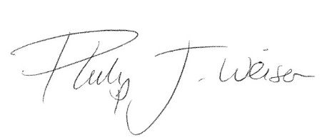

Leslie Rutledge Phil Weiser

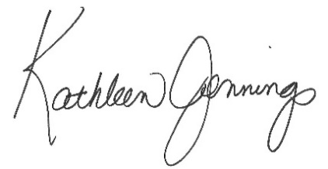Arkansas Attorney General Colorado Attorney General

Kathleen Jennings Ashley Moody

Delaware Attorney General Florida Attorney General

Christopher M. Carr Holly T. Shikada

Georgia Attorney General Hawaii Attorney General

Iowa Tom Miller.tifIdaho Lawrence Wasden.tif

Lawrence Wasden Tom Miller

Idaho Attorney General Iowa Attorney General

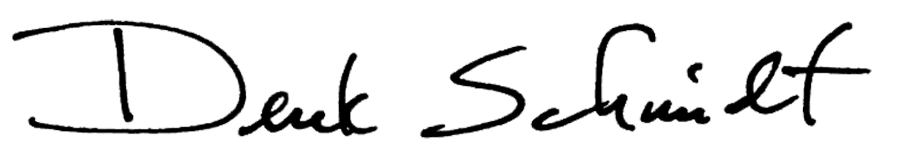

Derek Schmidt Daniel Cameron

Kansas Attorney General Kentucky Attorney General

Jeff Landry Aaron M. Frey

Louisiana Attorney General Maine Attorney General

Dana Nessel Douglas Peterson

Michigan Attorney General Nebraska Attorney General

Aaron D. Ford Matthew J. Platkin

Nevada Attorney General Acting New Jersey Attorney General

Inline image 1

Hector Balderas Josh Stein

New Mexico Attorney General North Carolina Attorney General

Drew. H. Wrigley Dave Yost

North Dakota Attorney General Ohio Attorney General

John O’ Connor Josh Shapiro

Oklahoma Attorney General Pennsylvania Attorney General

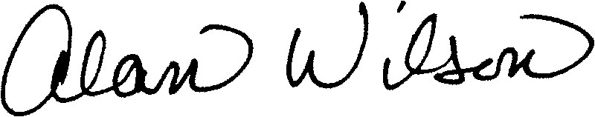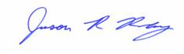

Alan Wilson Jason R. Ravnsborg

South Carolina Attorney General South Dakota Attorney General

Herbert H. Slatery III Ken Paxton

Tennessee Attorney General Texas Attorney General

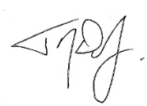

Sean D. Reyes T.J. Donovan

Utah Attorney General Vermont Attorney General

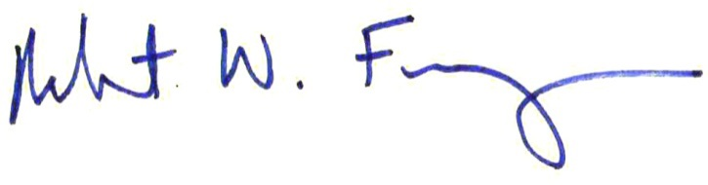

Denise N. George Robert W. Ferguson

Virgin Islands Attorney General Washington Attorney General

C:\Users\rrashatwar\AppData\Local\Microsoft\Windows\Temporary Internet Files\Content.Outlook\YI6WX1D9\AG Sig.tif

Patrick Morrisey

West Virginia Attorney General